Appendix B – TLP (Traffic Light Protocol)

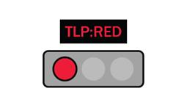
TLP:RED: This label means that the shared material is intended for the recipient only, and any further sharing is not permitted
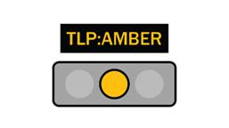
TLP:AMBER This label implies that the material can be shared with limitations, only when necessary within the organization and its constituents/clients.

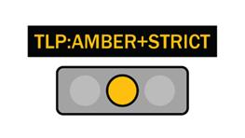
TLP:AMBER+STRICT This label restricts sharing within the organization, unlike TLP:AMBER, where information can be shared with constituents/clients.

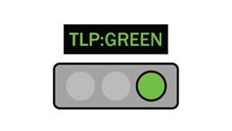
TLP:GREEN This label represents limited information sharing, but it can be shared with the entire recipient community. This type of information should not be shared through publicly accessible communication means.
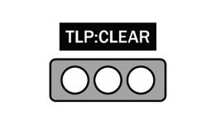
TLP:CLEAR This label represents information that can be publicly shared, and there are no restrictions on sharing.
Color Codes for TLP Labels:
RGB:
TLP:RED : R=255, G=0, B=51, background: R=0, G=0, B=0
TLP:AMBER : R=255, G=192, B=0, background: R=0, G=0, B=0
TLP:GREEN : R=51, G=255, B=0, background: R=0, G=0, B=0
TLP:CLEAR : R=255, G=255, B=255, background: R=0, G=0, B=0
CMYK:
TLP:RED : C=0, M=100, Y=79, K=0, background: C=0, M=0, Y=0, K=100
TLP:AMBER : C=0, M=25, Y=100, K=0, background: C=0, M=0, Y=0, K=100
TLP:GREEN : C=79, M=0, Y=100, K=0, background: C=0, M=0, Y=0, K=100
TLP:CLEAR : C=0, M=0, Y=0, K=0, background: C=0, M=0, Y=0, K=100

